OFFER LE

«ACCOUNT_NAME»
«Address»
Dear Sir/Ma,

07/09/2026

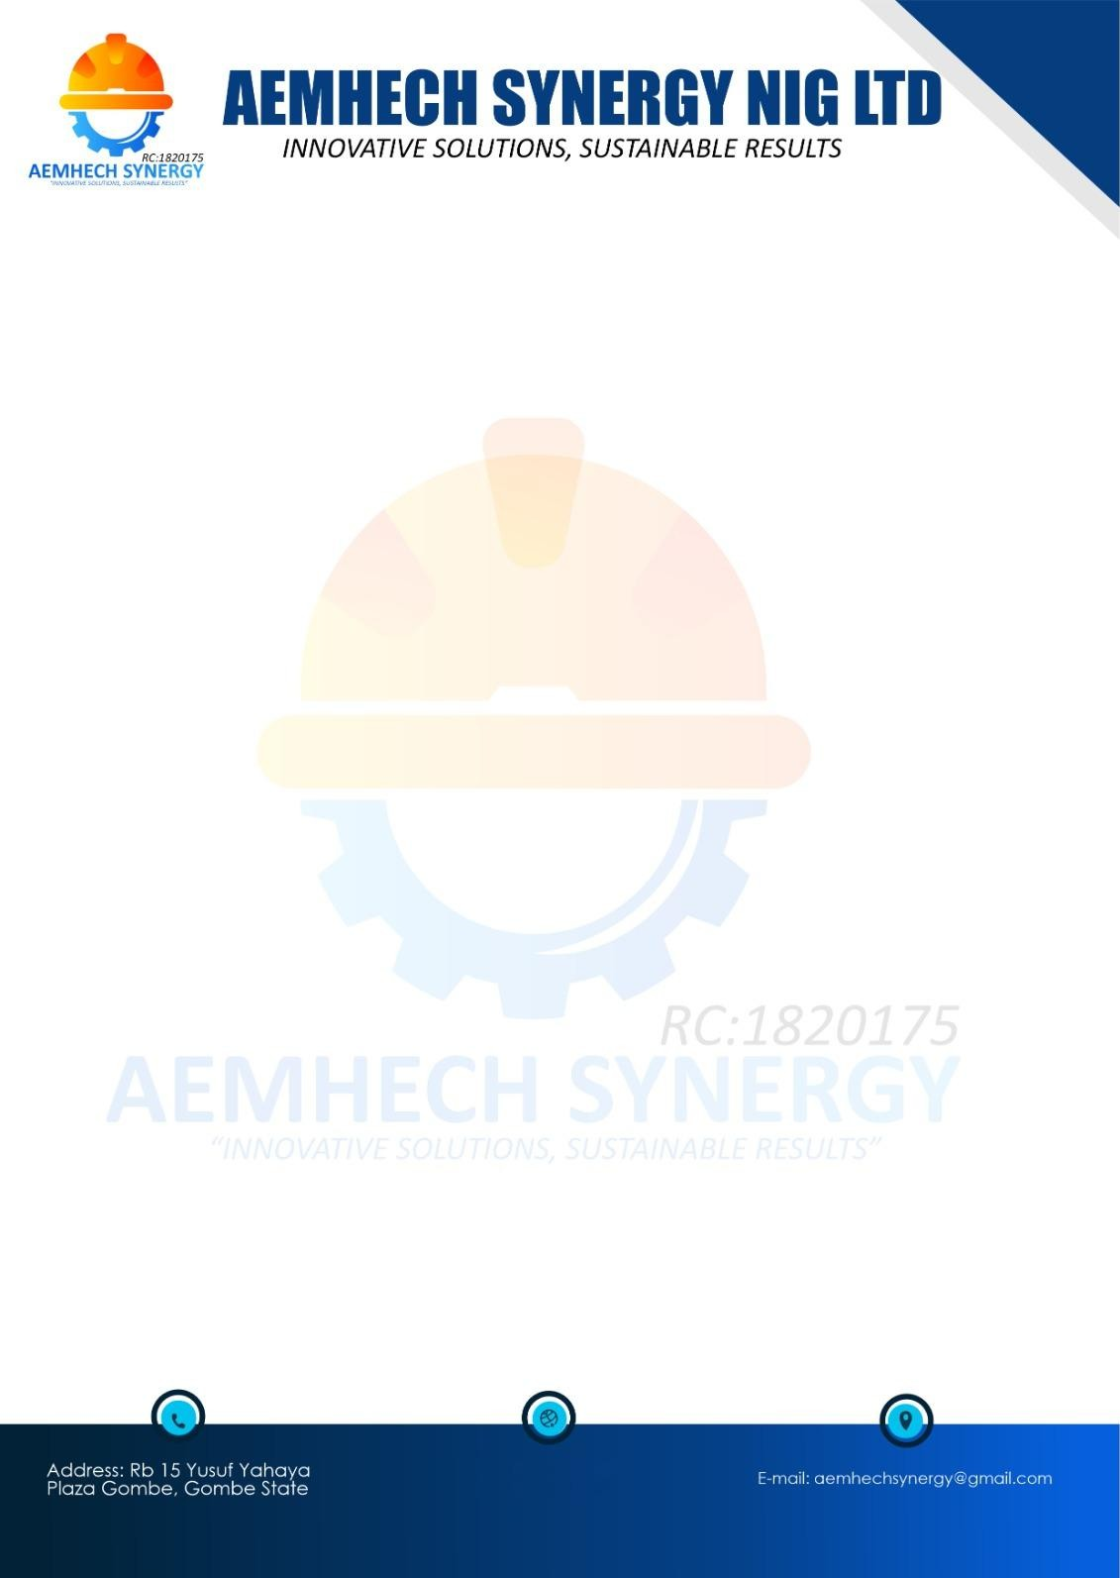

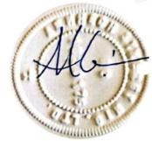
OFFER LETTER FOR THE PURCHASE OF HOUSING UNIT AT JIBI VILLAGE, DEI DEI ROAD, KUBWA EXPRESS, ABUJA/NIGER STATE

Sequel to your interest in our Estate, we are pleased to offer you one Housing Unit of
Executive 1 Bedroom Semi-detached flat at JIBI VILLAGE, DEI DEI ROAD, KUBWA EXPRESS, ABUJA/NIGER STATE. The details of the offer are as follows:
Description: 1 Unit of Executive 1 Bedroom Semi-detached flat
Type of Use: Strictly Residential
Purchase Price: ₦«Purchase_price» («Purchace_Price_Word») ONLY
Please note that this purchase price is valid for 3 calendar months and may be subject to review thereafter.

TERMS AND CONDITIONS OF OFFER
- You shall be bound by the terms and conditions for sale of the property as agreed by our company (AEMHECH SYNERGY NIG LTD).
- Your duration for the acceptance of this offer is 2 weeks from the date of receipt of this letter.
- This letter of offer is not transferable and not to be sold.
- The title Deed to the property will be transferred to you upon full payment for the value of the property.
- You must take possession of the property within 3 Months after Allocation.
- This offer is subject to revocation if the terms and conditions are not fulfilled.
- You shall provide your water digging a borehole or liaise with a close neighbour for conjunction.
- You shall purchase armoured cables for the purpose of tapping electricity from our feeder pillar to your house of choice.
- You shall pay a facility management fee payable for your house of choice renewable year on year.
You are required to pay the sum of ₦70,000 for Property Offer processing fees.
Please accept our hearty congratulations!

FOR: AEMHECH SYNERGY NIG LTD
Mubarak Bala MD/CEO

MEMORANDUM OF ACCEPTANCE

I «ACCOUNT_NAME»hereby accept this property offer letter on this day dated 08/09/2026 of which this is a copy.

Name: «ACCOUNT_NAME»

Address «Address»

Signature:

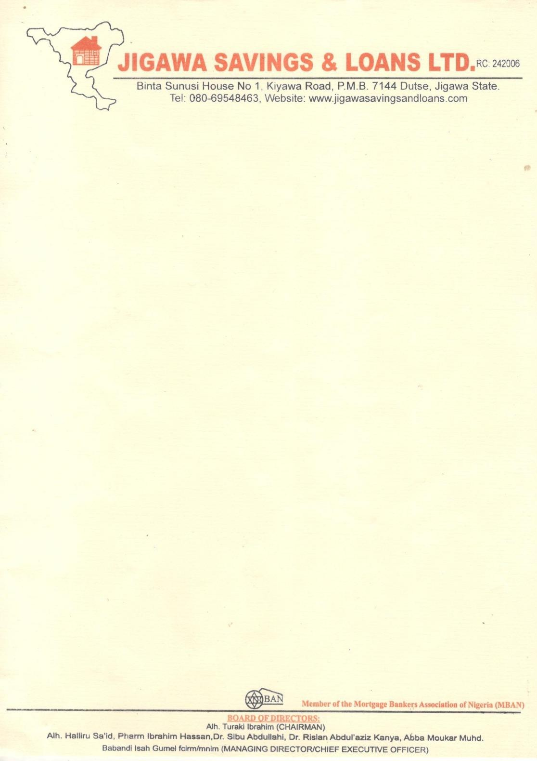
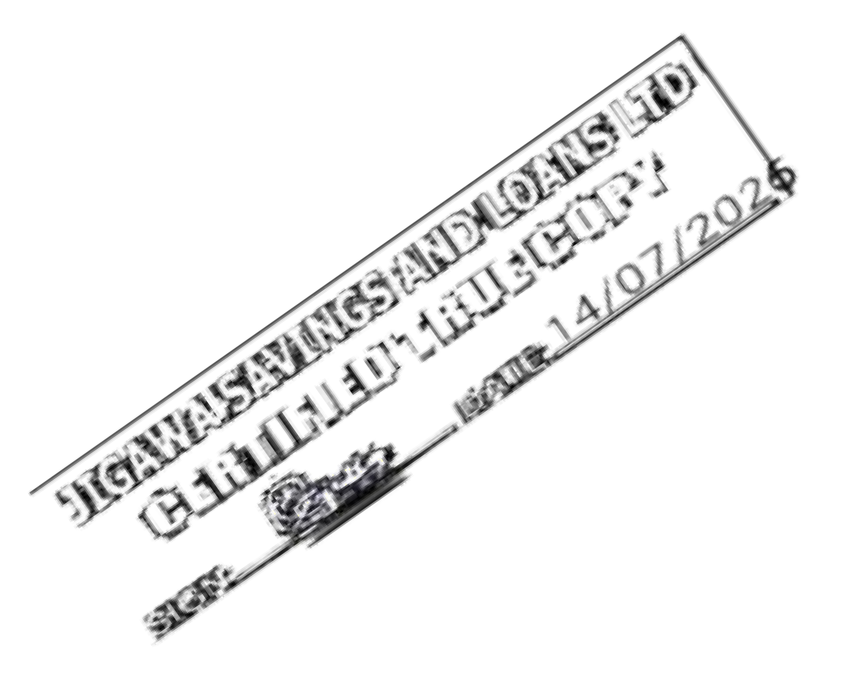

7th Sept, 2026
The Managing Director, ACCESS ARM PENSIONS,
Plot No. 339, Cadastral Zone A08, Takwa Crescent, Off Adetokunbo Ademola Crescent,
Wuse 2, Abuja.

LETTER OF INDEMNITY IN RESPECT OF RETIREMENT SAVINGS ACCOUNT EQUITY CONTRIBUTION
THIS INDEMNITY is issued by Jigawa Savings and Loans Limited of Binta sanusi house, No. 1 Kiyawa Road, Dutse, Jigawa State (hereinafter called “Indemnifier” which expression where the context so admits include its successors-in-title and assigns), to ACCESS ARM PENSIONS having its Head Office at Plot No. 339, Cadastral Zone A08, Takwa Crescent, Off Adetokunbo Ademola Crescent, Wuse 2, Abuja (Hereinafter called “ACCESS ARM PENSIONS” which expression shall where the context so admits include its successors-in-title and assigns)

WHEREAS:
- ACCESS ARM PENSIONS is a Pension Fund Administrator licensed by the National Pension Commission (“the Commission”) to manage individual Retirement Savings Accounts (RSA) in accordance with the provisions of the Pension Reform Act, 2014 (“the Act”);
- Pursuant to the Act, the Commission has issued Guidelines on Accessing RSA Balance towards Payment of Equity Contributions for Residential Mortgage (“Guidelines”) which Guidelines permit RSA Account Holders to access a portion of their RSA balance as equity contribution towards acquiring a residential property from a licensed financial institution;
- The Indemnifier is duly licensed by the Central Bank of Nigeria (CBN) and meets all the eligibility criteria for the provision of mortgage lending services to RSA holders under the Guidelines issued by the Commission.
- The Indemnifier has received applications from several RSA holders who maintain RSAs with ACCESS ARM PENSIONS and in line with the Guidelines, the indemnifier has agreed to finance the purchase of a residential property on behalf of the RSA holders, subject to the execution of relevant mortgage contracts.
- MUHAMMAD MUSTAFA MUHAMMAD, the RSA holder has requested and authorized that a portion of his/her RSA balance should be utilized as equity contribution to facilitate his/her mortgage and has applied to ACCESS ARM PENSIONS to release to the indemnifier, a portion note more than 25% of his/her RSA balance as equity contribution towards the acquisition of a residential mortgage.
- The indemnifier has conducted all requisite due diligence to confirm the authenticity of the RSA holder’s intended acquisition of a residential property and undertakes to ACCESS ARM PENSIONS that the portion of the RSA holder’s fund which shall be released to the Indemnifier on the RSA holder’s request shall be applied solely as equity contribution towards the acquisition of a residential mortgage, under the mortgage agreement between the indemnifier and the RSA holder; and shall not, under any condition, be released to the RSA holder or any third party for any other purpose.

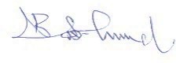
- ACCESS ARM PENSIONS agrees to release the relevant portion of the RSA holder’s fund to the indemnifier and has requested that the Indemnifier provides this indemnity in favour of ACCESS ARM PENSIONS in the manner hereinafter stated.

NOW THEREFORE, in consideration of ACCESS ARM PENSIONS effecting the transfer of the portion of the RSA holder’s balance to the indemnifier as equity contribution by the RSA whose holder whose RSA PIN herein appears, towards acquisition of residential property in accordance with the Guidelines, We, Jigawa Savings and Loans Limited hereby irrevocable and unconditionally covenant that we shall at all times hereafter, indemnify ACCESS ARM PENSIONS and keep ACCESS ARM PENSIONS fully indemnified against all claims, demands, liabilities, actions, damages, penalties and legal proceedings (including any cost of litigation) which may be incurred by ACCESS ARM PENSIONS in the event that the fund so released by ACCESS ARM PENSIONS is not utilized as equity contribution towards the purchase of a residential property on behalf of the RSA holder.
Furthermore, Jigawa Savings and Loans Limited undertakes to pay ACCESS ARM PENSIONS on demands, liabilities, actions, damages and expenses (including but not limited to legal fees) incurred by the ACCESS ARM PENSIONS from acceding the RSA holder’s request to release funds from his/her RSA, in the event that the fund so released by ACCESS ARM PENSIONS is not utilized as equity contribution towards the purchase of a residential property on behalf of the RSA holder.
This Indemnity shall be continuing security and shall be enforceable from the date of disbursement of the portion of the RSA holder’s balance to the Indemnifier and shall inure to the benefit of ACCESS ARM PENSIONS up until the utilization of the funds so released, as equity contribution towards the acquisition of the residential property in favour of the RSA holder by the Indemnifier
This Indemnity shall not be enforceable against the Indemnifier for any claims, demands, of litigation, arising from any dispute or breach howsoever, in the contractual relationship between the ACCESS ARM PENSIONS and the RSA holder.
The indemnification provided under this indemnity by the Indemnifier shall be completely discharged upon the utilization of the portion of the RSA holder’s balance towards the purchase of a residential property in favour of the RSA holder by the Indemnifier.

RSA HOLDER | RSA PIN
«ACCOUNT_NAME» | «PIN_NUMBER»
This indemnity shall be governed by and construed in accordance with the extant laws of the Federal Republic of Nigeria.
THE COMMON SEAL of the within named INDENIFIER JIGAWA SAVINGS AND LOANS
LIMITED was hereunto affixed I the presence of:


Director Director/Secretary

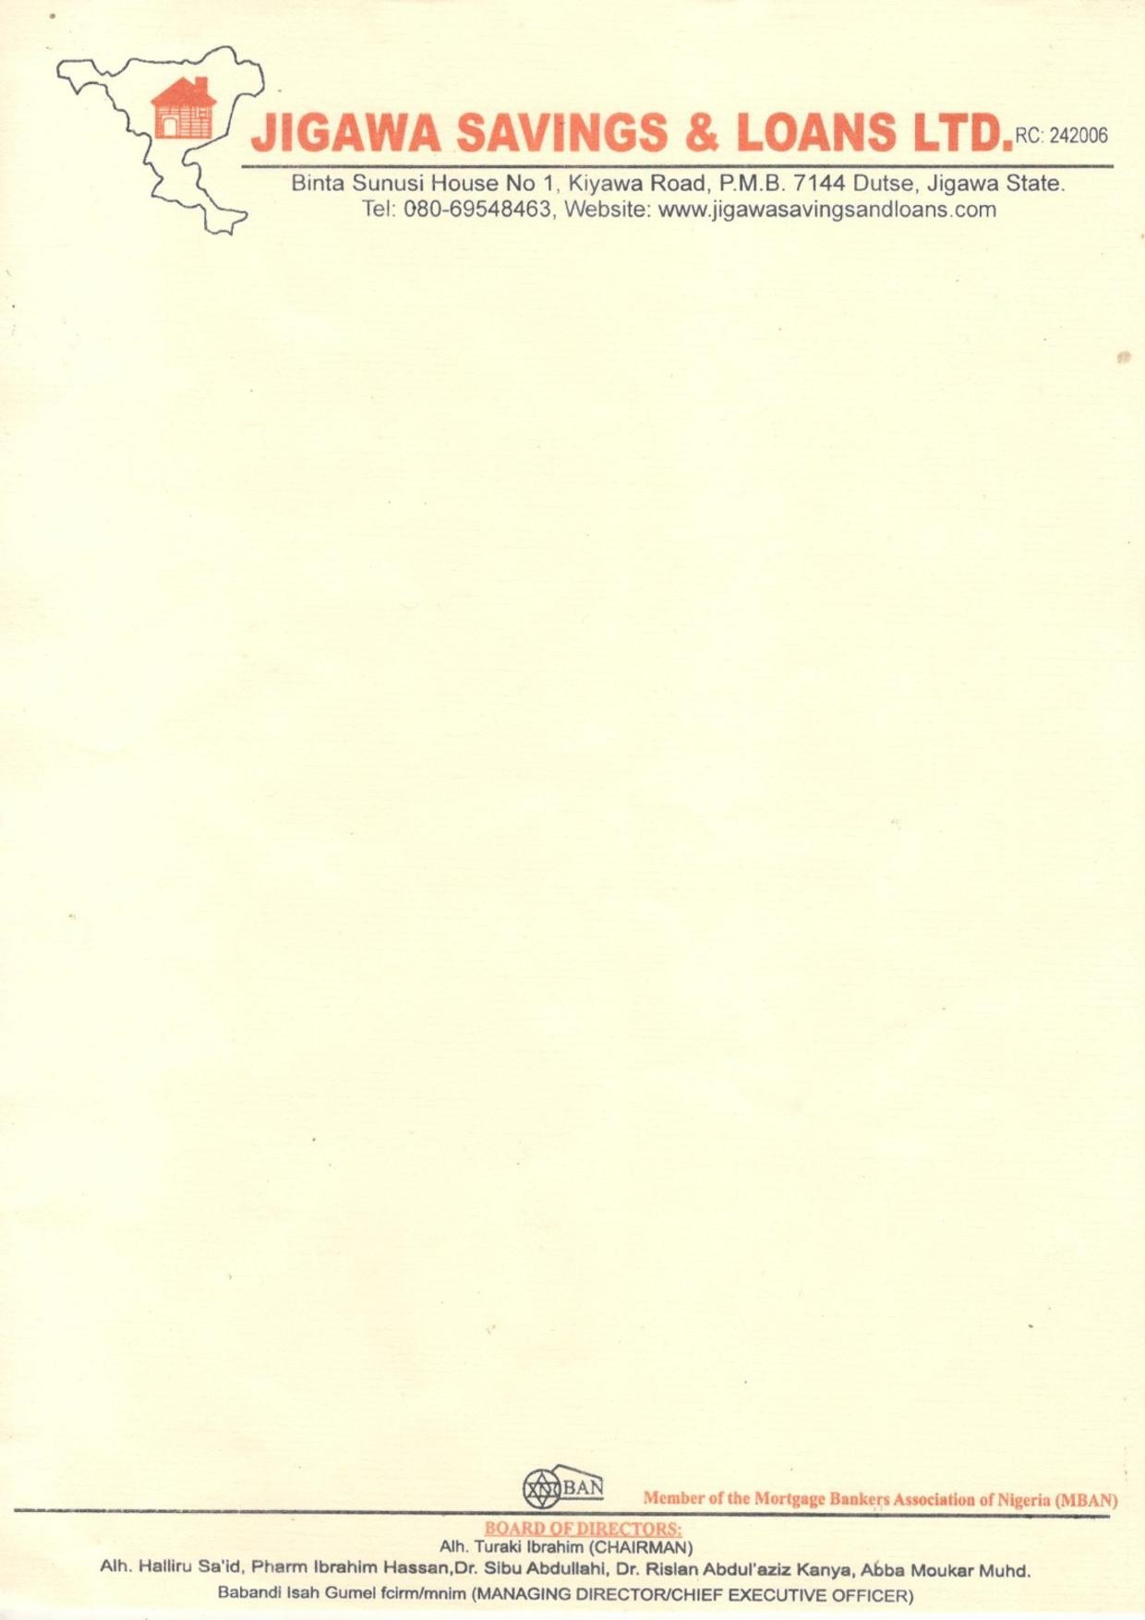
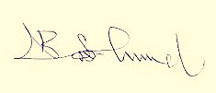


14th July, 2026
The Managing Director, ACCESS ARM PENSIONS,
Plot No. 339, Cadastral Zone A08, Takwa Crescent, Off Adetokunbo Ademola Crescent,
Wuse 2, Abuja .
Dear Sir,

VERIFICATION OF OFFER LETTER FOR THE PURECHASE OF AN EXECUTIVE 1 BEDROOM SEMI-DETACHED FLAT AT JIBI VILLAGE, DEI DEI ROAD, KUBWA EXPRESS, ABUJA/NIGER STATE
The above subject matters refer.
The property was visited on the 20th February, 2026 to ascertain the availability of the property.
The property an EXECUTIVE 1 BEDROOM SEMI-DETACHED FLAT, AT JIBI VILLAGE, DEI DEI ROAD, KUBWA EXPRESS, ABUJA/NIGER STATE
Offered to «ACCOUNT_NAME». The sale value of the property as of date is ₦<<PuRCHASE_PRICE>> («PURCHASE_PRICE_word») ONLY.
In view of forgoing, ‘We confirm the authenticity of the property offer letter and other documents’ as well as the availability of the property for sale.
Thanks for your usual co-operation. Yours faithfully,
For: Jigawa Savings and Loans Limited

Aminu Jinjiri Babandi Isah Gumel
Head of Mortgage Managing Director/CEO

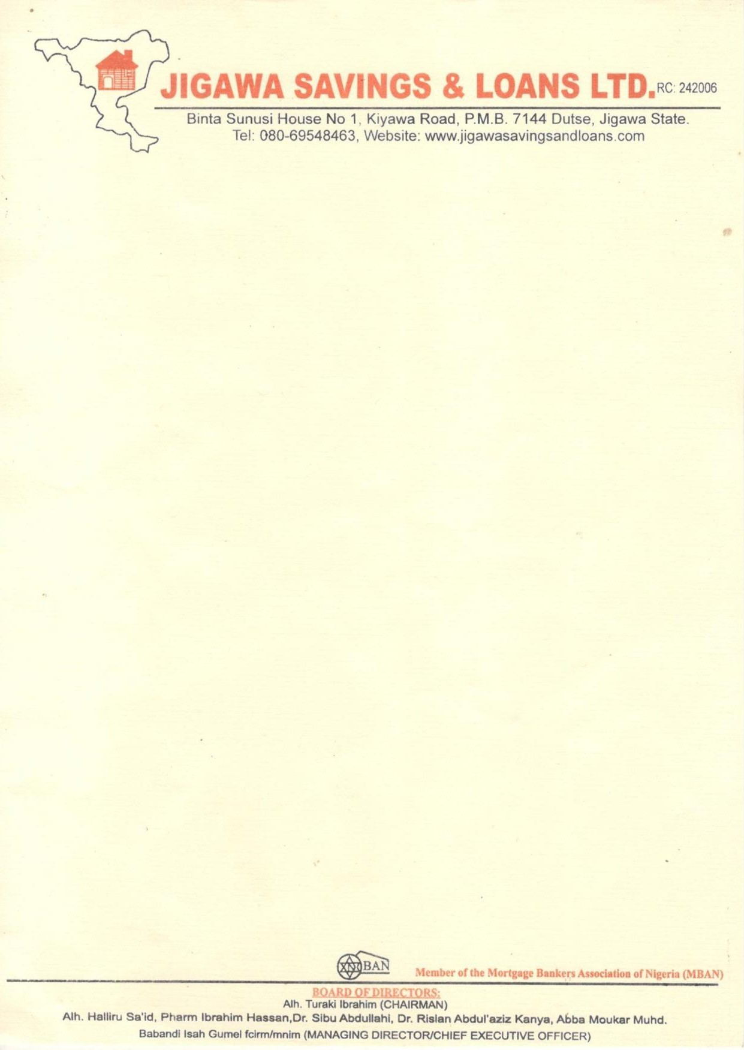
14th July, 2026

MUHAMMAD MUSTAFA MUHAMMAD

HOUSE NO 2ALTERNATEDANBATTABRIDGE RUGA MARARABA.
Dear Sir,
INDICATIVE OFFER LETTER OF A MORTGAGE LOAN OF ₦200,000.00 (TWO HUNDRED THOUSAND NAIRA) ONLY FOR THE PURCHASE OF EXECUTIVE 1 BEDROOM SEMI-DETACHED FLAT AT JIBI VILLAGE, DEI DEI ROAD, KUBWA EXPRESS, ABUJA/NIGER STATE.
Further to your application Mortgage Loan Jigawa Savings and Loans Limited (JSL) is pleased to offer you a Mortgage Loan of ₦ 200,000.00 (Two Hundred Thousand Naira) only, subject to the following terms and conditions.
Borrower - «ACCOUNT_NAME»
Lender - Jigawa Savings and Loans
Type of facility - JSL Loan
Property Amount - ₦ «PURCHASE_PRICE»
Facility Amount - ₦200,000.00
Purpose - for the purchase of Executive 1 Bedroom Semi-detached flat, Jibi, village, Dei Dei Road, Kubwa Express, Abuja/Niger State.
Equity - ₦ «Equity_Contribution» (to be contributed from: 25% RSA Equity Contribution)
Tenor - 7 years effective from the date of disbursement
Repayment plan - The principals together with the accrued interest shall
Be repaid in 12 equal monthly repayments of ₦ 19,166.67
Interest Rate: - 15% per annum on amity basis
ACCOUNT DETAILS WITH MORTGAGE LENDER:
ACCOUNT NAME: «ACCOUNT_NAME»
ACCOUNT NUMBER: «ACCOUNT_NUMBER»
BANK: JIGAWA SAVINGS AND LOANS LIMITED
Kindly use the above account details for the payment of the 25% funds upon approval in favour of the customer

Repayment source:- The mortgage facility shall be repaid by monthly repayment deduction from the Mortgagor’s salary or/ and business proceeds.
Security - The facility shall be secured by the following First Legal Mortgage over property to the Mortgage.
- Direct deduction through Remita or IPPIS
- Duly executed Irrevocable Letter of Authority for the Domiciliation of Mortgagor’s Terminal Benefits with JSL
- Letter of Undertaking to Offset any outstanding obligation with JSL noted as loss payee.
Insurance: JSL shall on behalf and at the cost of the Mortgagor Comprehensively insure the property with a reputable insurance company against fire and other special perils with JSL noted as loss payee.
Disbursement: The facility amount shall be disbursed in full into the mortgagor current account.
STATUTORY PAYMENT REQUIREMENT:
Charges:
  - Management fee of 1% flat of the approved loan amount of ₦2,000 Payable upfront to JIGAWA SAVINGS AND LOANS LIMITED.
  - Fees of stamping, registration, perfection and other statutory fees payable to the appropriate authorities shall be communicated in due course
  - Processing fee of 2% flat of the 25% RSA equity contribution fund in the sum of
₦«Processing_fee_»
CONDITIONS PRECEDENT TO DISBURSEMENT
- Receipt of the duly executed offer later by the mortgagor accepting the terms and conditions of the facility.
- Payment of all outstanding charges and fees upfront.
- Deposit of equity contribution ₦ «Equity_contribution» to be contributed by the RSA equity fund
- Execution of all loan with JSL These include
  - JSL’s Loan Agreement
- Deed of Legal Mortgage on the Collateral Property
- Deed of Assignment on the Collateral Property
- Irrevocable Power of Attorney on the Collateral Property
- Indemnity clause not to divert funds

- Receipt of up-to-date payment of ground rent and/or land use charge receipts
- Submission of Photo Identification of the mortgagor
- Receipt of current tax clearance certificate of the mortgagor
- Deposit for the cost of perfecting title in favour of Jigawa Savings And Loans Limited
- Submission of duly executed letter of domiciliation of Terminal Benefits
- Opening of current account with JSL by the Mortgagor
- Receipt of evidence of compliance with all the Insurance conditions.
- Receipt of undertaking from the Mortgagor to regularly find the current account for
monthly repayment of the loan, annual Insurance premium, ground rent and other related charges
- Submission of original registered Title Document of the collateral property (C of 0. Deed of Assignment or Deed of Transfer or Deed of Conveyance)
- Submission of duly signed consent letters authorizing JSL to disclose information to Credit Reference Agencies to determine history and rating of the mortgagor.
- Disbursement is subject to receipt of 25% of RSA Contribution
- Receipt of undertaking of set-off of the loan and other dues from the mortgagors account as and when due.
- The Mortgagor providing 1 year premium for property insurance policy as first loss payee
- All costs and expenses incidental to the processing, monitoring documentation, disbursement, and recovery of the facility, including the perfection of the Security
Collateral Property as well as the cost of enforcing the terms and conditions therein. Shall be fully bome by the Mortgagor
- Payment of 2% penalty fee on loan balance for early liquidation of loan.
STAND BY CREDIT LINE
  - All termly repayment of the loan, annual premiums, ground rent and related charges shall be debited to the mortgage’s current account under advice.
- In the event the mortgagee’s current account is not funded to meet any of the payment (refereed to in 1 above) JSL shall provide a stand-by credit line in form of an overdraft to meet such payments.
- In the events of 2, above, the mortgage still pay a management fee 1% of any amount outstanding in the account per month in addition to interest to interest at the Bank’s
leading rates as may be determined from time to time.
- The security for the stand-By credit Line shall be the subject property

- In the event of delay in the repayment due to an unforeseen occurrence, the Mortgagor must escalate same to the bank prior to payment due to date and must subsequently apply in writing for a short terms overdraft to cover the period as clause (2) above.
- Some Remedies for Defaults
The Bank remedies against the Borrower’s defaults included buy not limited to:
  - The bank is also authorized to liquidate all other collaterals provided by me in the cause of security this approval: by way of outright sale of such collaret and the proceeds
should be used to clean up, y outstanding.
  - The facility shall become payable. The mortgage by accepting this offer has by way of first priority hereby assigned a security Jigawa Savings And Loans Limited, the collated property with the building (s) erected thereon. The bank cam therefore, exercise its full right of FORCLOSUE OUTRIGHT SALE without any recourse to the Borrower
  - Irrevocable and unconditional authority to JSL to publish the Borrower’s name without any recourse to the Borrower’s newspaper circulating within Nigeria.

“By signing this offer letter/loan agreement and by drawing on the loan as and when due. In the I fail to repay the loan as agreed, and the loan becomes delinquent, the bank shall have the right to the report the delinquent loan to the CBN through the credit Risk Management System (CRMS) or by any other means, and request that CBN exercise its regulatory power to direct all banks and other financial Institutions under its regulatory purview to set – off my indebtedness from any money standing to my credit in any bank account and from any other financial assets they may be holding for my benefit.
I covenant and warrant that the bank shall have power to set – off my indebtedness under this loan agreement from all such monies and funds standing to my credit/benefit it any and all such accounts or from any other financial assets belonging to me and in the custody of any such bank.

I «ACCOUNT_NAME»
……… with BVN
«BVN»

And NIN «NIN» hereby undertake that in case of any incapacitation or sudden demise in the course of the loan, Jigawa savings and loans LTD is permitted to offset our outstanding loan balances from the sales of our property used as collateral for this loan.

08/09/2026
Borrower’s Signature/Date
I HAVE READ AND UNDERSTOOD THE CONTENT OF THIS OFFER LETTER AND HEREBY AGREED/CONSENT TO SAME

If the foregoing terms and conditions are acceptable to you, please indicate your acceptance by signing the attached duplicate copy of this letter and return to us failing which the offer shall lapse without any liability or commitment on the part of JSLL.
Yours Faithfully
For: JIGAWA SAVINGS AND LOANS LTD
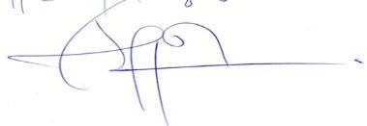
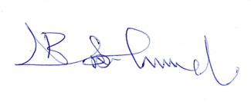
Aminu Jinjiri Babandi Isah Gumel
Head Of Mortgage Managing Director/CEO

UNDERTAKING
I «ACCOUNT NAME» Hereby undertake and consent to the monthly deductions of the monthly repayment from my current account until the loan is fully understood all the duration of the Mortgage and hereby confirm that I have read and understood all the terms and conditions of this offer.
Signature: Date: 8th Sept, 2026
OFFER ACCEPTED BY: In the Presence of:

Name:
«ACCOUNT NAME»
Name: «NEXT_OF_KIN»

Signature: ………………………………… Signature: ………………………………… Date: 8TH Sept, 2026 Date: 8th Sept 2026
Mobile number: «PHONE» Mobile number: «PHONE»


VALUATION REPORT

ON
PROPERTY LOCATED AT JIBI VILLAGE, DEI DEI ROAD, KUBWA EXPRESS, ABUJA/NIGER STATE.

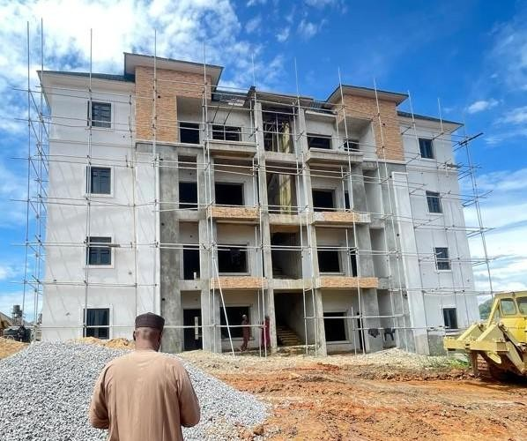

FOR

«ACCOUNT NAME»

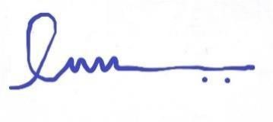
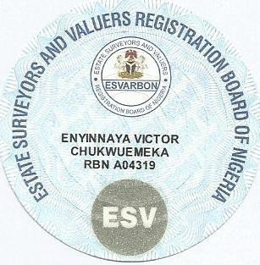
CERTIFICATE OF VALUE

DATE OF VALUATION: 10th June, 2026
PURPOSE OF VALUATION: Determination of Fair Market/Forced
Sale Values

This is to Certify
That the Fair Market Value of the Interest in the subject landed property situated at JIBI VILLAGE, DEI DEI ROAD, JIBI EXPRESS,
ABUJA/NIGER STATE, as at the above valuation is in the sum of
₦«Purchase_price» («Purchace_Price_Word» only) and the Forced Sale Value in the sum of ₦«Forsale_value» «Forsale_value_word»only).

We hereby certify that the above exercise has been carried out in conformity with the Professional standards of the Nigerian Institution of Estate Surveyors and valuers of which we are registered members.

Given under our Seal and Witnessed by the Signature of our Principal Consultant by Virtue of Powers conferred upon him by the Estate
Surveyors And Valuers Registration Board of Nigeria

This 6th Day of Sept, 2026



VAL/ABJ/VEC/2026

The Managing Director
Jigawa Savings and Loans Limited
Binta Sunusi House No 1, Kiyawa road, Dutse. Jigawa State.

Dear Sir,

6th Sept, 2026.

VALUATION OF PROPERTY LOCATED AT JIBI VILLAGE, DEI DEI ROAD, JIBI EXPRESS, ABUJA/NIGER STATE.
Further to your recent instruction requesting us to undertake a Valuation of the above--captioned property, we have carried out the inspection and valuation of same and now have the pleasure in reporting to you as follows:
DATE OF INSPECTION:

Our inspection was undertaken on Saturday the 10th day of June, 2026.

- PROPERTY LOCATION:
Access to the property is either via Jibi Village, Dei Dei Road, Jibi Express, Abuja/Niger State.

Driving from Jibi Express Way Abuja to Dei Dei in Niger State and right turn will lead you to Jibi Village, the area is adjacent to Brain Hammers Estate in the same Jibi Village in Tafa LGA, Niger State.

The Neighborhood Comprise of mainly residential buildings.

VICTOR ENYINNAYA ASSOCIATES

ACCESSIBILITY:
The roads are tarred to the estate.

Basic infrastructural facilities such as electricity, pipe--borne water, telecommunication and adequate road network are available within the precinct.

DESCRIPTION:

Our interest is on a single unit of Executive 1 Bedroom Semi-detached flat.

NEIGHBOURHOOD:

JIBI DISTRICT:
Jibi is a fast developing district in Niger State. It is a mixed of high income and middle class relatively secured area which is located in Niger State, but very close to the FCT--Abuja. Jibi is residential development. It is home to several estates, mostly new and under construction couple with commercial buildings. Jibi district boasts well tarred and untarred roads, very good transportation networks too.

PREDOMINANT HOUSING UNIT:

Housing types within the neighborhood comprise mainly of Terrace duplex, block of flats, semi--detached and fully detached duplex.
Notable structures within the precinct are Brain and Hammers estate.

VICTOR ENYINNAYA ASSOCIATES

VALUATION:

CONSTRUCTIONAL DETAILS:
The unit will upon completion, have the following constructional details:

1 BEDROOM BLOCK OF FLAT
Construction is of sandcrete block walls.
The walls are rendered smooth and finished with emulsion paint.
The floors are of the reinforced mass in--situ concrete, finished with ceramic tiles The doors are of the security type.
The windows are of the aluminum swing type. The ceiling is of the Plaster of Paris (P.O.P) type.
The roof is of the aluminum long span roofing sheet type nailed unto timber trusses.

ACCOMMODATION DETAILS:
The following are the details of accommodation provided in the building: MAIN BUILDING
- Living room
- Dining
- Guest toilet
- Kitchen
- 1 Bedroom ensuite

VICTOR ENYINNAYA ASSOCIATES

TOPOGRAPHY/SITE:
The site is regular in shape, appears firm, leveled and well drained. TITLE:
The title document to the property is Letter of intent (Mass Housing) title to the property is good and marketable.
This is however subject to the provisions and limitations of the Land Use Decree No. 6 of 1978.
However, we did not carry out a title search on the property and no responsibility is assumed for matters legal in character.

METHOD OF VALUATION:

A. We have valued the property in the open market using the direct comparison method of valuation.
The direct comparison method involved our analysis of similar properties that have recently been transacted upon in the open market within the locality and adjusting appropriately to take care of the peculiarities and level of completion of the subject property in arriving at the value.

CONDITION:

The buildings are in a good state of structural and decorative repairs.

However, we did not carry out a structural survey of the buildings, neither did we examine nor test their services. We are, therefore, unable to comment in this regard.
Similarly, we did not inspect the materials used for the construction and cannot give any guarantee or assurance that they are free from rot, woodworm or any such infestations.

VICTOR ENYINNAYA ASSOCIATES

SCHEDULE OF CONDITION

S/N | BUILDING COMPONENTS | DEFECTS | REMARK
1 | Wall | None | None
2 | Doors | None | None
3 | Floor | None | None
4 | Window | None | None
5 | Roof | None | None

INFORMATION:
Information given in this report have been obtained as follows:
- as regards the descriptive and locational details from visual inspection of the property; ;
- as regard the value from analysis of open market transactions on similar properties in the neighborhood;
- as regards the title, from assumptions made by us.

ASSUMPTIONS:
In valuing the property, we have assumed:
- that the information with which we are supplied are correct;
- that the title to the property is good and marketable;
- that the property is not adversely affected by or subject to compulsory acquisition, road widening, new proposal or planning scheme;
- that the property is free from all onerous charges and restrictions.

VICTOR ENYINNAYA ASSOCIATES



VALUATION BASIS:
The basis of valuation is the Market value, that is, the price, which an interest in a property might reasonably be expected to realize in a sale by Private Treaty assuming:
- a willing buyer;
- a reasonable period within which to negotiate the sale taking into account the nature of the property and the state of the market;
- values will remain static throughout the period;
- the property will be freely exposed to the market;
- no account is to be taken of an additional bid by a special purchaser;
- no account is to be taken of expenses of realization, which may arise in the event of a disposal.

CERTIFICATION:
In carrying out our valuation, we certify that:
  - statement of facts with regards to this report are true and correct to the best of our knowledge;
  - Limiting conditions have been disclosed;
  - we have no interest (present or future) in the transaction or property;
  - Compensation was not contingent upon us rendering our opinion of value;
  - We have complied with all valuation standards as required;
  - An inspection of the property was conducted;
  - Assistance was not received in the execution of the valuation report.

VICTOR ENYINNAYA ASSOCIATES

OPINION:

WE ARE OF THE OPINION that the Market value of the above--captioned property as at the 10th of June, 2026 is in the sum of ₦«Purchase_price» («Purchace_Price_Word» ONLY).

WE ARE FURTHER OF THE OPINION that the Forced sale value of the above--captioned property as at the 10th Day of June, 2026 is in the sum of

₦«Forsale_value» («Forsale_value_word»Only).

This Certificate is issued for the use of the addressee only and no responsibility is accepted from any third party for the whole of its contents or any part thereof.

If our opinion of value is to be disclosed, the basis of our valuation should please be stated and if our figure is to be published, it will be necessary for our prior consent to be obtained for the form and context in which it will be published.



VICTOR ENYINNAYA ASSOCIATES

ALLY MICROINSURANCE LIMITED
Suite C4, 29 Ndjamena Crescent Wuse II, Abuja. Email: allymicroinsurance@gmail.com Tel: +2348165555948

CERTIFICATE OF INSURANCE

FIRE MICROINSURANCE PLAN

POLICY NO: ALLY/2026/FIR/0455
NAME OF POLICY
HOLDER:
«ACCOUNT_NAME»

ADDRESS: «RESIDENTIAL_ADDRESS»

NAME OF PROPERTY: EXECUTIVE 1 BEDROOM SEMI-DETACHED FLAT
ADDRESS OF PROPERTY: JIBI VILLAGE, DEI DEI ROAD, JIBI EXPRESS,
ABUJA/NIGER STATE.
EFFECTIVE DATE: 25/05/2026
EXPIRATION DATE: 24/05/2027
GROSS PREMIUM: ₦ «Fire_Insurance»
SUM ASSURED: ₦ «Sum_Insured»

We hereby certify that the policy to which this certificate relates is issued in accordance with the NATIONAL INSURANCE COMMISSION MICROINSURANCE GUIDELINE 2018.:
Examined:
GABRIEL LOT-LINUS Authorized Signature

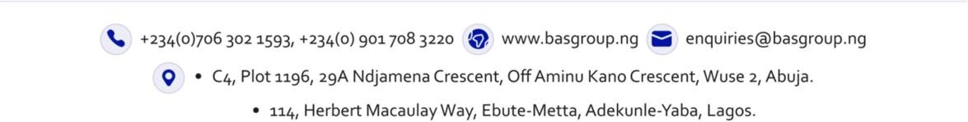

ALLY MICROINSURANCE LIMITED
Suite C4, 29 Ndjamena Crescent Wuse II, Abuja. Email: allymicroinsurance@gmail.com
Tel: +2348165555948

CERTIFICATE OF INSURANCE

CREDIT LIFE MICROINSURANCE PLAN

POLICY NO: ALLY/2026/CRT/0461
NAME OF POLICY
HOLDER:
«ACCOUNT_NAME»

ADDRESS: «RESIDENTIAL_ADDRESS»
NAME OF PROPERTY: EXECUTIVE 1 BEDROOM SEMI-DETACHED FLAT

ADDRESS OF PROPERTY: JIBI VILLAGE, DEI DEI ROAD, JIBI EXPRESS
ABUJA/NIGER STATE.
EFFECTIVE DATE: 25/05/2026
EXPIRATION DATE: 24/05/2027

GROSS PREMIUM: ₦ «Fire_Insurance»
SUM ASSURED: ₦ «Sum_Insured»

We hereby certify that the policy to which this certificate relates is issued in accordance with the NATIONAL INSURANCE COMMISSION MICROINSURANCE GUIDELINE 2018.
Examined:
GABRIEL LOT-LINUS Authorized Signature


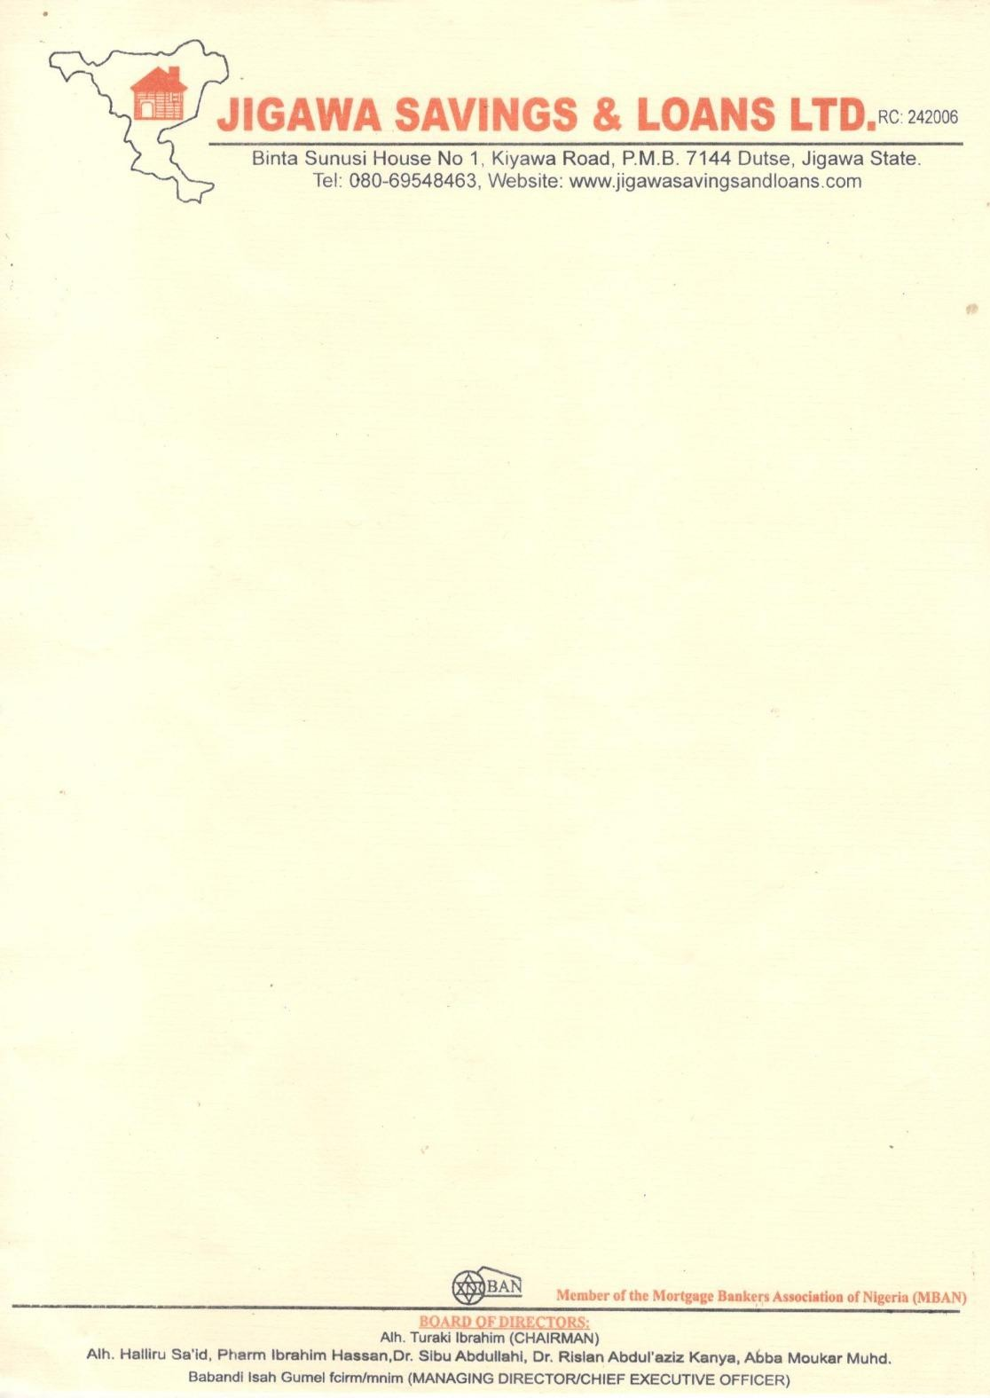


7th Sept, 2026.
The Managing Director,
ACCESS ARM PENSIONS,
Plot No. 339, Cadastral Zone A08, Takwa Crescent, Off Adetokunbo Ademola Crescent, Wuse 2, Abuja .

Dear Sir,

CONFIRMATION OF THE PROPERTY AVAILABILITY FOR MUHAMMAD MUSTAFA MUHAMMAD
We hereby write to official conform that the property a 1 Unit of Executive 1 Bedroom Semi-detached flat at JIBI VILLAGE, DEI DEI ROAD, KUBWA EXPRESS, ABUJA/NIGER STATE
Offered to «ACCOUNT_NAME»
Is very much available.
Please go ahead with his 25% RSA Residential Mortgage. Thank you for your co-operation

For: Jigawa Savings and Loans Limited

Aminu Jinjiri Babandi Isah Gumel
Head of Mortgage Managing Director/CEO

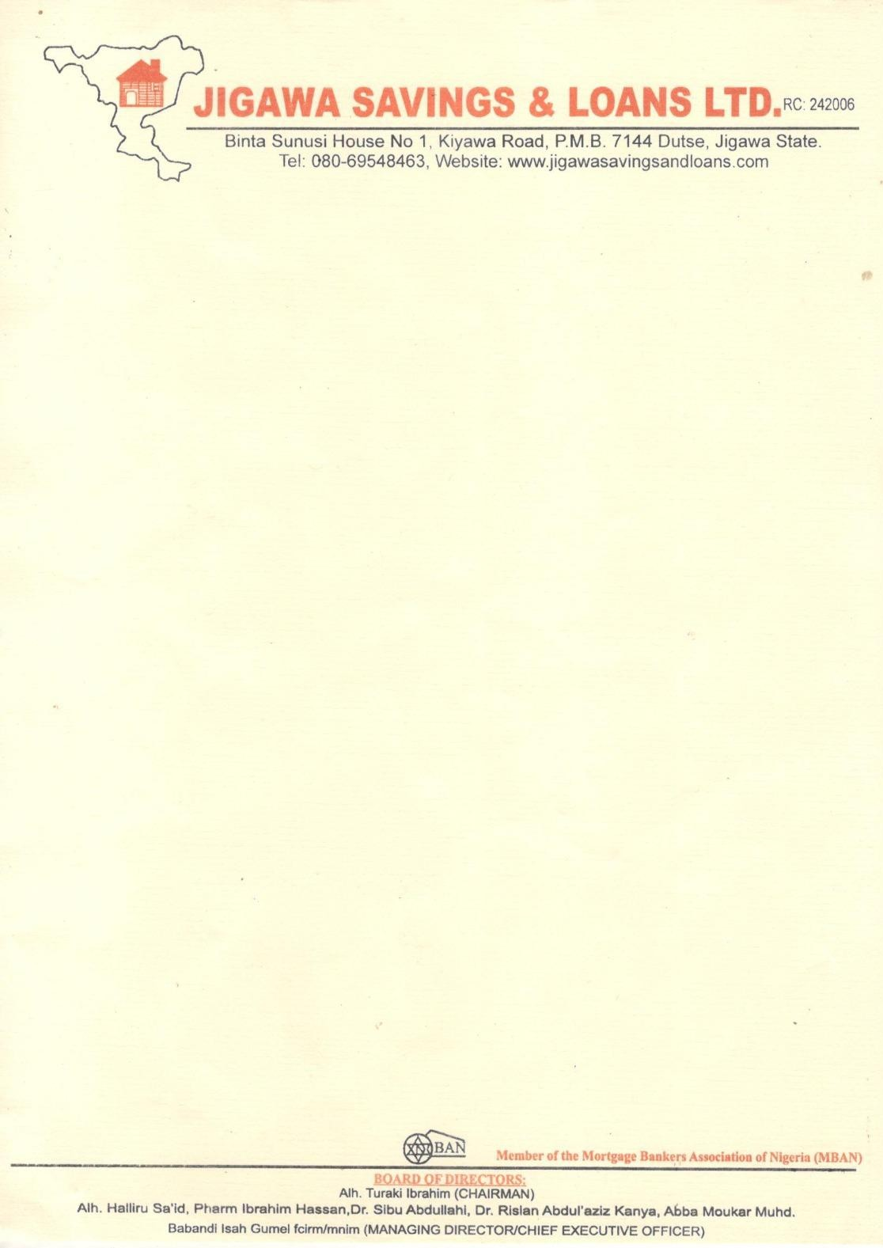
7th Sept, 2026.
The Managing Director,
ACCESS ARM PENSIONS,
Plot No. 339, Cadastral Zone A08, Takwa Crescent, Off Adetokunbo Ademola Crescent, Wuse 2, Abuja .

Dear Sir,

CONFIRMATION OF TITLE DOCUMENT OF PROPERTY KNOWN AS 1 UNIT OF
EXECUTIVE 1 BEDROOM SEMI-DETACHED FLAT, AT JIBI VILLAGE, DEI DEI ROAD, KUBWA EXPRESS, ABUJA/NIGER STATE IN FAVOUR OF «ACCOUNT_NAME»
PIN: «PIN_NUMBER»
We refer to the above subject and wish to confirm that a search was conducted to confirm the authenticity of the property document and it was confirmed that the property is free from all encumbrances.
We do hope this will assist you in the final processing
While we appreciate you for your anticipated cooperation, please note that we are duly prepared for immediate disbursement of the funds to the rightful beneficiary.
Thank you for your usual cooperation
Yours faithfully
For: Jigawa Savings and Loans Limited

Aminu Jinjiri Babandi Isah Gumel
Head of Mortgage Managing Director/CEO

The Managing Director,
ACCESS ARM PENSIONS,
Plot No. 339, Cadastral Zone A08, Takwa Crescent, Off Adetokunbo Ademola Crescent, Wuse 2, Abuja .
7th Sept, 2026.

Dear Sir,

EXPRESSION OF READINESS TO DISBURSE LOAN
We hereby express our readiness as a Mortgage Bank to disburse a loan of N200,000.00 Two Hundred Thousand Naira Only to «ACCOUNT NAME» with Jigawa Savings and Loans Mortgage Bank Account Number «ACCOUNT NUMBER».
Kindly credit the customer account details stated above with the sum of
₦«Equity_Contribution» Only being his 25% retirement savings, as an equity contribution for the purchase of a 1 UNIT OF EXECUTIVE 1 BEDROOM SEMI-DETACHED FLAT AT JIBI VILLAGE, DEI DEI ROAD, KUBWA EXPRESS, ABUJA/NIGER STATE.
Alternatively, you can transfer the fund to our Sterling Bank account details below:
Account name: Jigawa Savings and Loans Limited Account Number: 0007873093
Narration: 25% equity contribution for «ACCOUNT NAME» - «ACCOUNT_NUMBER»

Thank you for your anticipating co-operation Yours faithfully,
For: Jigawa Savings and Loans Limited

Aminu Jinjiri Babandi Isah Gumel

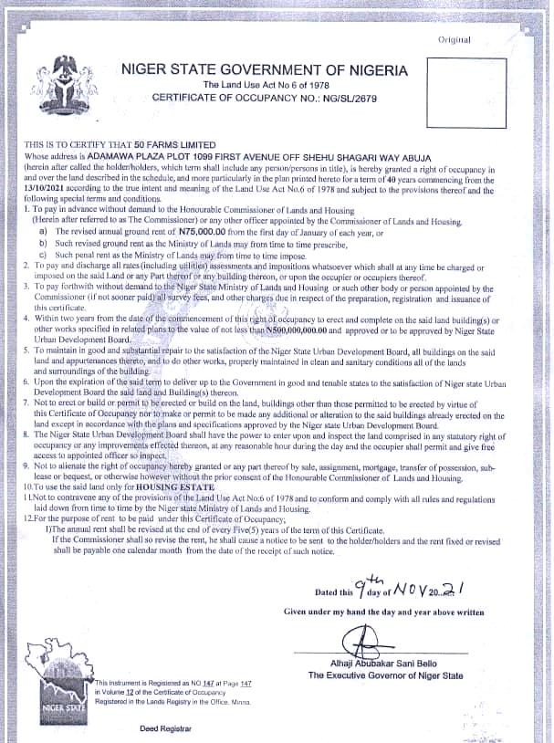
Head of Mortgage Managing Director/CEO

Approv

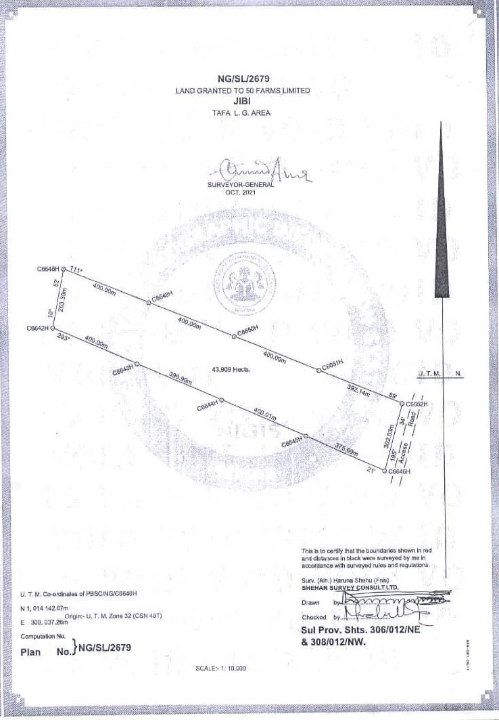
of


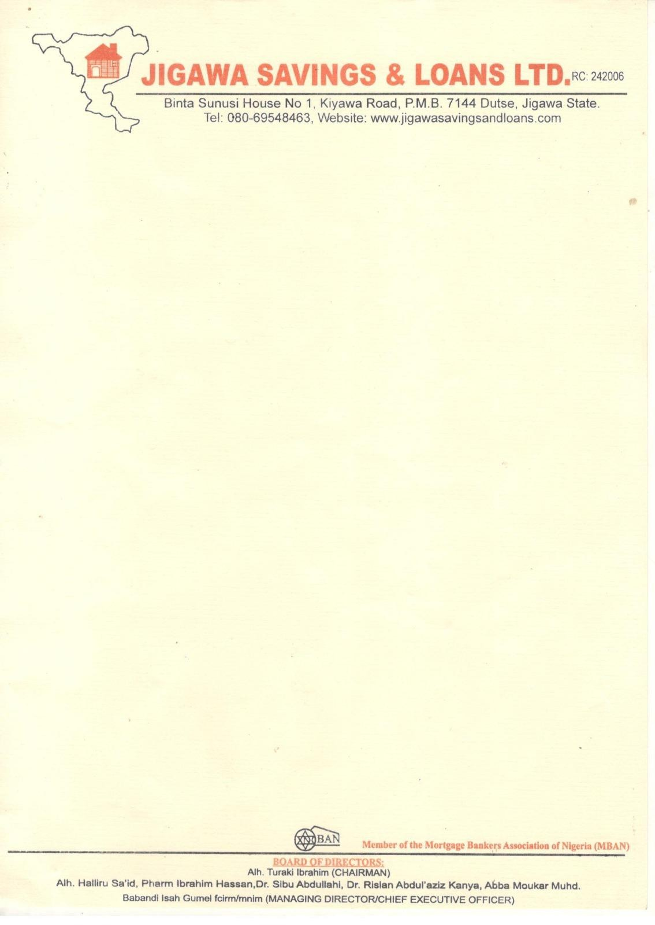

LEGAL SEARCH REPORT IN RESPECT OF NIGER STATE GOVERNMENT OF NIGERIA CERTIFICATE OF OCCUPANCY NO. NG/SL/2679 DATED 9th NOVEMBER, 2021 ISSUED BY THE NIGER STATE GOVERNMENT IN FAVOUR OF MUHAMMAD MUSTAFA MUHAMMAD.

1. | Date and Time of Search: | 2nd June, 2026 at 3:48 PM
1. | Place of Search: | Niger State Urban Development Board
2. | Full Description of Land: | All that parcel of land measuring approximately 439,090 m² square metres described and known as Jibi Village, Dei Dei Road, Kubwa  Express, Abuja/Niger State.
- Parties: 1. NIGER STATE URBAN DEVELOPMENT
BOARD(Grantor) AND
  - «ACCOUNT_NAME» (Grantee)
- Description of Title Document: Offer of Grant of Development Lease File No.
NG/SL/2679 dated 9th November, 2021 issued by the Grantor in favour of the Grantee.
- Term/Commencement Date: Twenty-four (24) months commencing from the 9th November, 2021.
- Purpose Commercial/Mass Housing Development
- Notable/Special Terms Clause 4 of the Title Document search provides that the holder shall not build or permit to
be built on the said land any buildings other than those approved to be built by the aforementioned Title Document.

Clause 8 of the Title Document search provides that within 24 months from the date of commencement of the Grant of the Offer, the Grantee must erect buildings on the land in conformity with the purpose for which the land was granted.
Clause 9 of the Title Document search provides that the holder is not to alienate the right of occupancy granted either by way of sale, assignment, mortgage or sublease (inter alia) without the prior written consent of the Niger State Urban development Board.
- Notable Observation: 1. «ACCOUNT_NAME» application dated 9th November, 2021 for direct allocation for land use for mass housing was acknowledged.
- Also sighted was proof of payment of N75,000 for processing of the aforementioned application.
- A Deed of Development Lease dated 9th November, 2021 between Niger State Urban Development Board and MUHAMMAD MUSTAFA
MUHAMMAD for the
development of mass housing was sighted.
- The Offer of Grant of Development Lease dated 24th June 2024 issued by the Niger State Urban Development Board in favour of MUHAMMAD MUSTAFA MUHAMMAD was
sighted.
- Sighted on search was the initial Bill for the Offer and Letter of Acceptance by MUHAMMAD MUSTAFA MUHAMMAD
but no evidence of the payment of the Initial Bill.
- by a Memorandum of Agreement dated 1st January, 2025 between MUHAMMAD MUSTAFA MUHAMMAD
on the one hand and AEMHECH SYNERGY NIG LTD on the other hand, AEMHECH SYNERGY NIG LTD
was handed over 18 hectares of land carved out from the parcel of land measuring 439,090 m² square metres for the construction of housing estate.
- AEMHECH SYNERGY NIG LTD has
parcellated the said 43 hectares of

land into a layout, which has been duly approved by NIGER STATE URBAN DEVELOPMENT BOARD and
has constructed mixed house types on the afore-stated land called the AEMHECH SYNERGY investment estate, to be sold to members of the public.
- AEMHECH SYNERGY NIG LTD has,
via a Property Sale Offer Letter offered a portion of the said land with the building thereon to «ACCOUNT_NAME»
2. Charges/Encumbrance: As at the date and time of this search, there is no evidence at NIGER STATE URBAN DEVELOPMENT BOARD of any
charges or encumbrances against the Title Document which will prevent the alienation on and transfer of a portion of the land with the building thereon by MUHAMMAD MUSTAFA MUHAMMAD through AEMHECH SYNERGY NIG LTD in favour of MUHAMMAD MUSTAFA
MUHAMMAD by way of sale.

We conclude that under the aforementioned Memorandum of Agreement dated 2nd June, 2026 in 9 .6 above, the Property Sale Offer Letter issued by AEMHECH SYNERGY NIG LTD is valid. «ACCOUNT_NAME» as good title to the land search against and its power to alienate its interest in a portion of the said land through AEMHECH SYNERGY NIG LTD to «ACCOUNT_NAME» by way of
assignment is un-encumbered.



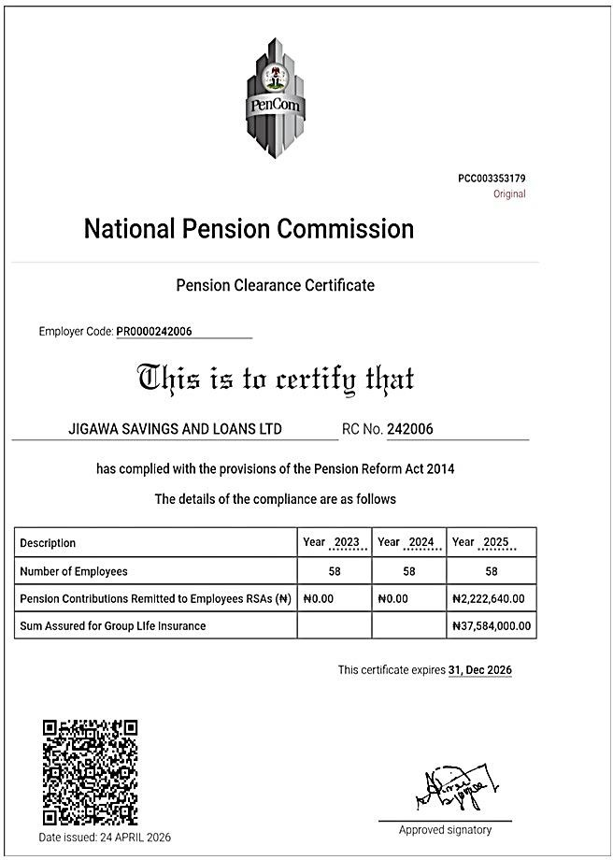

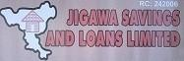
«ACCOUNT_NAME» Account Number: 0001450861

«ADDRESS»
Account Product: 25% RSA CURRENT ACCOUNT
Branch Name: HEAD OFFICE
Date From: 01-Jul-26
Date To 14-Jul-26
Brought Forward: 0.00Cr

Posting Date | Value Date | Transaction Narrative | Reference | Debit | Credit | Balance
14-Jul-26 | 14-Jul-26 | No transaction between 01-  Jul-2026 and 14-Jul-2026 |  | 0.00 | 0.00 | 0.00Cr
Count: 1 0.00 0.00

Carried Forward: 0.00Cr

*** End of Statement ***


RC: 242006
JIGAWA SAVINGS & LOANS LTD

Binta Sanusi House, No. 1, Kiyawa Road, P.M.B 7144 Dutse, Jigawa State

25% RSA EQUITY FUND ASSESSMENT APPLICATION FORM

PFA DETAILS
«ACCOUNT_NAME»
- Name of Applicant (RSA holder): …… …………………………….
- PFA: ……AC…CE…SS…A…RM……PE…NS…IO…N…S ………………………………………………………………………..
«PIN_NUMBER»
- PIN:……………..………………………………………………….
- Name of Mortgage Lender : ………JI…GA…W…A…SA…VI…NG…S…&…LO…A…NS…L…TD…………………………..
«ADDRESS»
- Address : ………………………………………………….
- Type and Address of property:……¹ …^{UN}…^{IT} …^{OF}…^{EX}…^{EC}…^{UT}…^{IVE}…¹…^{BE}…^{DR}…^{OO}…^{M}…^{SE}…^{M}…^{I-D}…^{ETA}…^{C}…^{HE}…^{D} ^{F}…^{LA}…^{T} ……
……A…T J…IB…I VI…LLA…G…E, D…EI…DE…I R…OA…D,…KU…BW…A…EX…PR.E.…SS,…AB…UJ…A/…NIG…ER…ST…AT…E ……………………………………….
- Type of Mortgage Offer (Single or Joint): …S…IN…GL…E……………………………………….
- Evidence of Marriage(If in a joint mortgage): ……………………………………………
- PIN of spouse(If in a joint mortgage): ……………………………………………..………..
- PFA of spouse(If in a joint mortgage): ……………………………………………………….
- Amount of Equity payable by each applicant (If in a joint mortgage) :
«EQUITY_AMOUNT»
……₦…………………………………………………………………………………………
- Mortgage Account Number:
«ACCOUNT_NUMBER»
- Value of Property:
«PROPERTY VALUE»
- Amount of Equity Payable:
«DOB»
«PROPERTY VALUE»
- Date of Birth:
- Sex:
- Marital Status: …………………………………………………………………………..

OTHER DETAILS
- Residential Address:
«ADDRESS»
………………………………………………………………………………………………………………..
Is it Owner-Occupier?…………………………..Or Rented?...................................
- Occupation: …CI…VI…L S…ER…V…AN…T…………………………………………………………………………..
- Date Employed: ………………………………………………………………………………………
- Office Address: ………………………………………………………………………………………..
…………………………………………………………………………………………………………………
- Present Position: …………………………………………………………………………………….
- Telephone No:
«PHONE»
- Mortgage Lender (Loan option as supplementary fund)
…………………………………………………………………………………………………………………

- Purpose of Loan Required: ……RE…SI…DE…N…TI…AL…M…O…RT…GA…G…E …………………………………..
- Amount of Loan Required: (In words/Figures) …………………………………………
……………₦…2…00…,0…00…(T…W…O…H…UN…D…RE…D…TH…O…U…SA…ND…N…A…IR…A)……………………………………………
- Repayment Period: ………1…2 MO…N…T…HS……………………………………………………………
- Monthly Salary/ Income: ………………………………………………………………………..
- Source of Loan Repayment: ……SA…L…AR…Y ……………………………………………………..
- BVN «BVN»
- NIN «NIN»

SPOUSE BIODATA
- Name: ………………………… ………………………………………………………………………….
- Address: ……….…………………………………………………………………………………………
…………………………………………………………………………………………………………………
- Occupation: …….………………………………………………………………………………………
- Address of Place of Work: …………………………………………………………………….…
…………………………………………………………………………………………………………………
- Present Rank : …………………………………………………………………………………………
- Date Employed (Public Servant only): ……………………………………………………..
- GSM Number : ………………………………………………………………………………………..

NEXT OF KIN BIODATA
- NAME: «NEXT_OF_KIN»
- Address: …«Address»
- Relationship: .………………………………………………………………………………………….
- Occupation: …………………………………………………………………………………………….
- Address of Place of Work: ……………………………………………………………………….
- GSM Number :… «phone»

DELARATION
I, Mal/Alh/Haj/Mr/Mrs M «ACCOUNT NAME» hereby
declare that the above information are true and correct and I shall comply with any other terms and conditions as stipulated by the bank as requirements for the loan.
Signature: …………………………………………………. Date: 8TH SEPT, 2026


APPLICATION FORM FOR 25% WITHDRAWAL AS EQUITY CONTRIBUTION FOR RESIDENTIAL MORTGAGEDETAILS

PERSONAL DETAILS
NAME «ACCOUNT NAME»
«PIN NUMBER»
RSA PIN……………………………………………………………………………………………………………………………………..
«PHONE»
PHONE NUMBER (1) ………………………………………..(2)………………………………………..
EMAIL ……………………………………………………………………………………………………………………………………….
RSA BALANCE ON DATE OF APPLICATION (N) ……₦…………………………………………….
«BALANCE»
EQUITY CONTRIBUTION (N) …………………………………………………………..
«EQUITY_CONTRIBUTION»
SUPPLEMENTARY EQUITY CONTRIBUTION (WHERE APPLICABLE) (N)……………………………………………………………………………………………….

PROPERTY DETAILS
DATE OF APPLICATION (DD/MM/YYYY)

TYPE OF MORTGAGE (SINGLE/JOINT): SINGLE JOINT
✓

NAME AND ADDRESS OF PROPERTY
SEMI DETACHED FLAT AT JIBI VILLAGE, DEI DEI ROAD, KUBWA EXPRESS, ABUJA/NIGER

TYPE OF PROPERTY (APARTMENT/FLAT, BUNGALOW, STOREY BUILDING, DUPLEX ETC)
1 UNIT OF EXECUTIVE 1 BEDROOM SEMI-DETACHED FLAT
«PROPERTY_VALUE»
VALUE OF THE PROPERTY
NAME AND ADDRESS OF THE MORTGAGE LENDER JIGAWA SAVINGS & LOANS LTD
BINTA SANUSI HOUSE, NO. 1, KIYAWA ROAD, P.M.B 7144 DUTSE, JIGAWA STATE

FOR JOINT MORTGAGE ONLY DETAILS OF SPOUSE 1
NAME RSA PIN

PHONE NUMBER (1) (2)

PFA EMAIL

DETAILS OF SPOUSE 1

NAME RSA PIN

PHONE NUMBER (1) (2)

PFA EMAIL

DETAILS OF SPOUSE 2

NAME RSA PIN

PHONE NUMBER (1) (2)

PFA EMAIL

DETAILS OF SPOUSE 3

NAME RSA PIN

PHONE NUMBER (1) (2)

PFA EMAIL
EQUITY CONTRIBUTION BY EACH PARTY

(I) FIRST APPLICANT  (I) SPOUSE (N) | (N)  1
 | 2
 | 3
TOTAL EQUITY (N)
SUPPLEMENTARY EQUITY CONTRIBUTION (WHERE APPLICABLE)(N)

APPLICANT(S) SIGNATURE

NAME SIGNATURE

NAME SIGNATURE

NAME SIGNATURE

NAME SIGNATURE

EVIDENCE OF MARRIAGE
Marriage Certificate  Letter from court
EQUITY CONTRIBUTION BY EACH PARTY

(I) HUSBAND (N)
- WIFE (N) 1
2
3
TOTAL EQUITY (N)

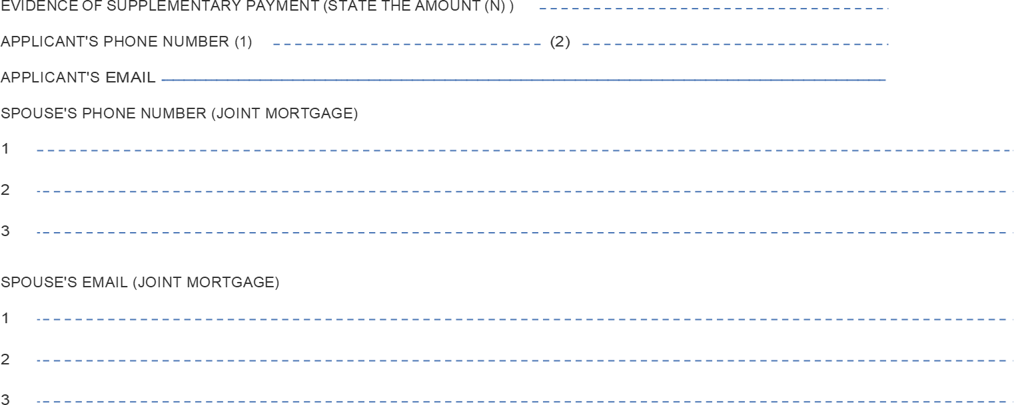
FOR OFFICIAL USE DOCUMENTATION CHECKLIST
S/N | Checklist | Received (YES/NO)
1 | Property o er letter from the owner showing the address of the building
2 | Complete application form with the PFA, Same for  spouse if joint mortgage from his/her PFA showing value, type and address of property
3 | Copy of application form with mortgage lender
4 | Valuation report on the property from licensed Estate surveyor and valuers
5 | Endorsed Retirement Savings Account Statement from PFA
6 | Signed letter from the mortgage lender stating that 25% of the RSA balance is adequate or not adequate to offset the equity contribution. If inadequate, letter must state  differential amount has been received by mortgage lender.
7 | Evidence of payment of additional Equity Contribution  where applicable
8 | Offer letter from the mortgage lender after meeting all requirements
9 | Bank Account details of the applicant with the  mortgage lender with attached statement of account or letter from the mortgage lender
10 | Completed indemnity form from applicant(s) sworn at  the high court.
11 | Completed indemnity form from Mortgage Lender.
12 | Birth Certi cate/Age Declaration
13 | Completed indemnity form from Mortgage Lender.

S/N | Checklist | Received (YES/NO)
14 | Recent passport photograph of each applicant(s) and spouse(s) for joint mortgage with his/her name at the back.
15 | Complete application form with the PFA, Same for  spouse if joint mortgage from his/her PFA showing value, type and address of property
Means of identifcation from the RSA holder, same for joint mortgage which can be from any one of the following:
- National Identity Card
- Valid International Passport
- Valid Driver’s License

CTC DOCUMENTS (FROM MORTGAGE LENDER)

S/N | Checklist | Received (YES/NO)
1 | Confirmation of title of property
2 | Cofirmation of availability of the property
3 | Insurance policies to cover default, replacement or  reinstatement cost of the property in case of any un-foreseen circumstances
4 | The valuation of the property carried out by a licensed, independent Valuer who is a member of Nigerian Institute of Estate Surveyors & Valuers (NIESV)
5 | Mortgage Lender Indemnity letter

AUTHORISED BY:

NAME |  | DESIGNATION
SIGNATURE |  | DATE
NAME  SIGNATURE |  | DESIGNATION  DATE

RSA HOLDER INDEMNITY FORM

The Chief Executive Access ARM Pensions
Adetokunbo Ademola Crescent, Wuse 2, Abuja

THIS INDEMNITY is issued by
«ADDRESS»
«ACCOUNT NAME»

of…..………………………………………………………………………….
… (hereinafter called "the Indemnitor", which expression
shall where the context so permits include its successors-in-title and assigns), to ACCESS ARM PENSIONS, having its Head Office at Off Adetokunbo Ademola Crescent, Wuse 2, Abuja (hereinafter called "ACCESS ARM PENSIONS", which expression shall where the context so permits include its successors- in-title and assigns)
WHEREAS:
- ACCESS ARM PENSIONS is a Pension Fund Administrator duly licensed by the National Pension Commission ("the Commission") to manage Retirement Savings Accounts (RSAs) in accordance with the provisions of the Pension Reform Act 2014 ("the Act");
- The Commission has, pursuant to the Act, issued Guidelines on Accessing RSA Balance towards Payment of Equity Contributions for Residential Mortgage ("Guidelines") which Guidelines permits an RSA holder to request for application of a portion of his/her RSA balance as equity contribution towards acquiring a residential property mortgage loan from a licensed financial institution;
- The Indemnitor is a holder of RSA with PIN
«PIN NUMBER»
and meets the eligibility criteria for the provision of
receiving mortgage services under the Guidelines issued by the Commission.

- The RSA holder has undertaken to make equity contributions to facilitate his/her mortgage and has applied to ACCESS ARM PENSIONS to release to the Mortgage Lender, a portion of his/her RSA balance as equity contribution towards his/her application for a residential mortgage.

Confidential

- ACCESS ARM PENSIONS agrees to release the relevant portion of the Indemnitor's RSA balance to the Mortgage Lender and has requested that the Indemnitor provides this indemnity in favour of ACCESS ARM PENSIONS in the manner hereinafter appearing.
NOW THEREFORE, in consideration of ACCESS ARM PENSIONS effecting the transfer of the portion of the Indemnitor's RSA balance to the Mortgage Lender as equity contribution by the Indemnitor whose RSA PIN appears herein towards acquisition of residential property in accordance with the Guidelines, l,
«ACCOUNT NAME»
………………………………. hereby irrevocably and unconditionally undertakes and covenant that I shall at all times hereafter well and truly indemnify ACCESS ARM PENSIONS and keep ACCESS ARM PENSIONS fully indemnified against all losses, claims, demands, liabilities, actions, damages, penalties and proceedings including any cost of litigation which may be incurred by ACCESS ARM PENSIONS in acceding to my request to transfer funds from my RSA to the Mortgage Lender.
This Indemnity shall be a continuing security and shall be in force until ACCESS ARM PENSIONS shall effectively discharge the Indemnitor from any action, penalty, claims, costs, expenses or liabilities that may be suffered by ACCESS ARM PENSIONS for acceding to request to transfer funds to the Mortgage Lender. However, this indemnity shall be inoperative and unenforceable where ACCESS ARM PENSIONS fails, refuses or neglects to comply with the provisions of the Commission's Guidelines or any other applicable substantive or subsidiary legislation(s) in relation to RSA holder's request.
This indemnity shall be governed by and construed in accordance with the laws of the Federal Republic of Nigeria.

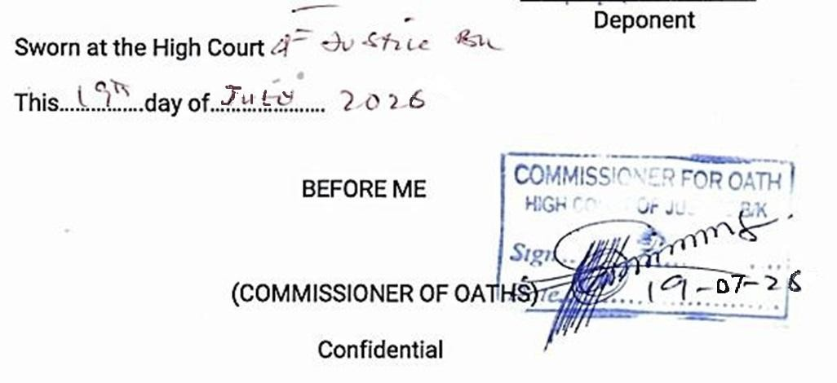

«Address»

THE MANAGER,
ACCESS ARM PENSIONS,
Plot No. 339, Cadastral Zone A08, Takwa Crescent, Off Adetokunbo Ademola Crescent,
Wuse 2 – Abuja.
.
DEAR SIR,
PAYMENT OF 25% EQUITY FOR RESIDENTIAL MORTGAGE
I wish to access twenty-five percent of my retirement savings account balance for the purpose of acquiring a house. I will be grateful if you can make the process seamless.
Thank You.

Yours Faithfully,

NAME:
«ACCOUNT NAME»
PIN:
«PIN_NUMBER»
PHONE NO:
«PHONE»
SIGNATURE:
DATE: 08/09/2026


CONSENT FORM TO ACCESS EQUITY CONTRIBUTION FOR MORTGAGE

CONSENT TO PAY FOR EQUITY CONTRIBUTION TOWARDS RESIDENTIAL MORTGAGE FROM MY RSA

I do hereby declare that I had been properly enlightened of the impact of accessing equity contribution for Residential Mortgage on my Retirement Savings Account (RSA) Balance.

Have you accessed your RSA due to Temporary loss of Employment?  YesNo

If yes, I acknowledge that having earlier accessed 25% of my Retirement Savings Account (RSA) balance due to loss of employment, I have been duly informed about the impact of applying 25% of my RSA balance as equity contribution for Residential Mortgage would have on my retirement benefits at retirement. I am also aware that the maximum allowable equity contribution accessible shall not be higher than 25% of the balance in my RSA.

Tick if this is a Joint Application 

Furthermore, I consent that application of a percentage of my RSA balance for equity contribution for residential mortgage shall be once, in line with the clause 3.4 of the Guidelines on Accessing the Retirement Savings Account balance towards payment of Equity Contribution for Residential Mortgage by RSA Holders.

Notwithstanding the above, I hereby authorize Access ARM Pensions to pay 25% of my RSA balance as at the date of submission of my request, as equity contribution for residential mortgage, irrespective of the percentage of equity contribution required by the Mortgage Lender. However, where the value of 25% of my RSA balance is higher than
the equity contribution required by the Mortgage Lender, I shall only access an amount equivalent to the equity contribution required by the Mortgage Lender. Conversely, where the value of 25% of the RSA is lower than the
equity contribution required by the Mortgage Lender, I shall deposit the difference with the Mortgage Lender before the release of 25% of my RSA balance by my PFA.

I have also been informed of the options to include my Voluntary Contributions contingent portion, NSITF and Pre-Scheme Contribution to augment the equity contribution in the event that 25% of my RSA balance is insufficient to pay the 25% equity contribution to the Mortgage Lender. Tick the box(es) below if you want to include any of the above options.

 VC Contingent NSTIF Pre Scheme Contribution Thank you for your co-operation.
Yours faithfully,
Name……M Mobile Number
«ACCOUNT NAME»
«PHONE»
RSA PIN Signature……………………………………………
72

